***Read this article then answer the questions on the following page in ENGLISH!***

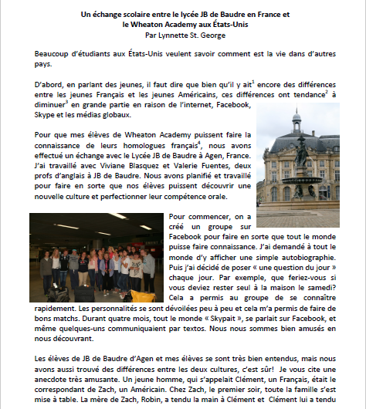

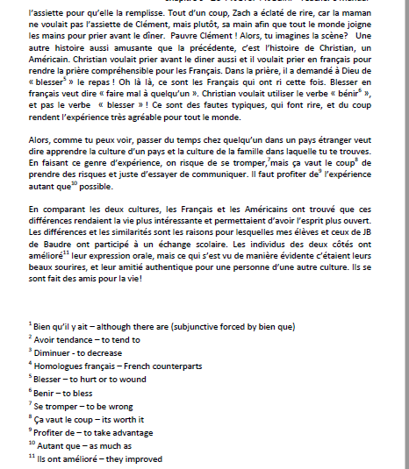

*Read the above article and answer the following questions in ENGLISH. This is an interpretive reading assessment. Only use the article to help you and do the best you can.*

1. **In English, type below one to two sentences describing what this article is generally about?**
2. **For the following section, read the statements given.**
3. If the statement is TRUE, type TRUE on the space below the statement AND provide proof of your answer.

For example: If the statement says, *There is a picture included in this article*..you would write TRUE and then the proof of that being true would be…. .*there is a photo of a building in Paris*. So your sentence will look like this..*True, there is a photo of a building in Paris* (and you should type this in the space below the statement.

1. If the statement is NOT true, leave it BLANK. FYI there will be mostly statements where you need to provide proof as in example (a)!
2. American students are curious about Europeans ***(if this is true, provide proof from the article in English by stating about what students are curious, if it is NOT true (the article does not include anything about students being curious or wanting to know something different) leave it blank and go on to the next question. This will be the procedure for all the following questions).***
3. Young people in general are minimizing this curiosity through modern methods.
4. There is an exchange between two schools.
5. These two schools are in East Asia and Africa.
6. The exchange happens initially through social media.
7. Students send packages, gifts and food to each other.
8. The teachers set up activities for students to become better acquainted through social media.
9. The teacher shares a funny story about misunderstanding a culture.
10. The French boy gets very nervous with his American family.
11. Words can be misleading in other languages.
12. Students participating in the program did benefit in some positive ways.
13. **Do you think that exchange programs are beneficial? Why or why not?**
14. **Which group would have a more difficult time adjusting to their new surroundings (the Americans in France or the French in the United States) Explain your answers by showing a real cultural comparison (use specific details about why you have that opinion).**